Validation Testing for Productivity Manager

1. To-Do List Validation Testing

* Testing Data:
* Task 1: “Walk 30 Min”
* Task 2: “Pay bills”
* Task 3: “Call Mom”

Results:

The To-Do List was tested with three tasks added successfully. Tasks were also deleted, crossed off, and uncrossed as expected. No issues were encountered during testing and the application performed as intended.

What I had to fix: My uncross would just delete initially so I fixed it so it greys out.

(Cross Off) (Delete Item) (Input Testing/Uncross)

2.Journal Validation Testing

* Testing Data:
* Date: “07-25-2023”
* Title: “Reflection”
* Journal Entry: “Today was a great day. I did some coding and went out to eat with friends.

Results:

The Journal was tested by adding a new entry with the data above. The entry was successfully saved. The “Show Previous Entries” button was also tested, and the previously saved entry works as expected. The application correctly validated the date format and ensure all fields were filled before saving the entry.

Fix: I had to fix the show previous entries because when I added the error message, the message still got saved.

(Journal Input Validation) (saved entries/saving works)

3.Input Validation Testing

* To-Do List: Attempted to add an empty task and submit.
* Journal: Attempted to save a journal entry without filling all fields (date, title, and journal)
* Journal Date Format: Attempted to save a journal entry with an incorrect date format.

Results:

The application handled input validation, displaying appropriate error messages for each case. The To-Do List prevented adding empty tasks, the Journal required all fields to be filled before saving, and it validated the date format for journal entries.

Fix: I had to fix the error message for the to-do list as it wasn’t working. The error message would not pop up.

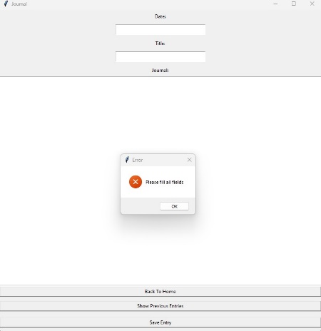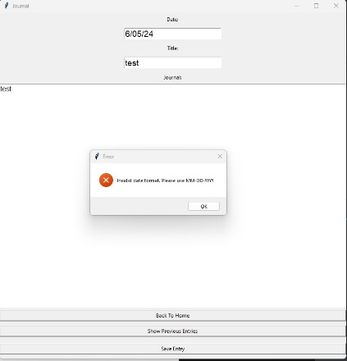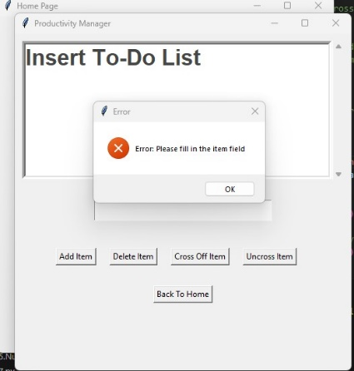

4.Exit Button Testing

* Test Data: Clicked the “Exit” button.

Results:

The application closed perfectly without any errors when the “Exit” button was clicked. All screens were closed and the application terminated successfully.

Fix: N/A